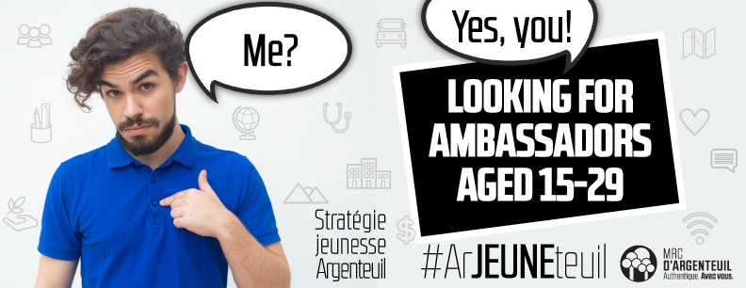

Are you between 15 and 29 years old, living in the MRC d’Argenteuil, and do you have great ideas and the desire to share them? We want YOU!

We are looking for inspiring and passionate young ambassadors because we need to know your vision of the MRC d'Argenteuil. We’re trying to build the future of our beautiful region, and to do so, we need to better understand the needs and aspirations of our youth.

Your role:

- Share your ideas on the place of young people in Argenteuil when it comes to:
- social ties between generations -living together-
- eco-responsibility
- the labour market and business development
- education, your dreams
… and how to live a healthy life doing it all!

- Encourage the young people in your entourage to participate in the Youth Strategy (Stratégie jeunesse) consultation, either by answering the online questionnaire or by taking part in a discussion group.

Interested? Would you like to learn more?

Contact Chantal Ranger:
cranger@argenteuil.qc.ca | 450 562-2474 ext. 2339

